**Semester 1 (Unit 3) Examination, 2017**

**Question/Answer Booklet**

**MATHEMATICS APPLICATIONS**

**Section One: Calculator-free**

Student Name/Number: ______________________________________________

Teacher Name: ______________________________________________

**Time allowed for this section**

Reading time before commencing work: five minutes

Working time for this section: fifty minutes

**Materials required/recommended for this section**

**To be provided by the supervisor:** This Question/Answer Booklet

Formula Sheet

**To be provided by the candidate:**

Standard items: pens (blue/black preferred), pencils (including coloured), sharpener,

correction fluid/tape, eraser, ruler, highlighters

Special items: nil

**Important note to candidates**

No other items may be taken into the examination room. It is **your** responsibility to ensure that you do not have any unauthorised notes or other items of a non-personal nature in the examination room. If you have any unauthorised material with you, hand it to the supervisor **before** reading any further.

**Structure of this paper**

|  |  |  |  |  |  |
| --- | --- | --- | --- | --- | --- |
| Section | Number of questions available | Number of questions to be answered | Working time (minutes) | Marks available | Percentage of exam |
| Section One: Calculator-free | 6 | 6 | 50 | 50 | 35 |
| Section Two: Calculator-assumed | 10 | 10 | 100 | 100 | 65 |
|  | | | | | 100 |

**Instructions to candidates**

1. The rules for the conduct of these exams are detailed in the *College assessment policy*. Sitting this examination implies that you agree to abide by these rules.
2. Write your answers in this Question/Answer Booklet.

3. You must be careful to confine your responses to the specific questions asked and to

follow any instructions that are specific to a particular question.

1. Spare pages are included at the end of this booklet. They can be used for planning your responses and/or as additional space if required to continue an answer.
   * Planning: If you use the spare pages for planning, indicate this clearly at the top of the page.
   * Continuing an answer: If you need to use the space to continue an answer, indicate in the original answer space where the answer is continued, i.e. give the page number. Fill in the number of the question that you are continuing to answer at the top of the page.
2. **Show all working clearly.** Your working should be in sufficient detail to allow your answers to be checked readily and for marks to be awarded for reasoning. Incorrect answers given without supporting reasoning cannot be allocated any marks. For any question or part question worth more than two marks, valid working or justification is required to receive full marks. If you repeat any question, ensure that you cancel the answer you do not wish to have marked.
3. It is recommended that you **do not use pencil**, except in diagrams.
4. The Formula Sheet is **not** to be handed in with your Question/Answer Booklet.

**Section One: Calculator-free 35% (50 Marks)**

This section has **6** questions. Answer **all** questions. Write your answers in the spaces provided.

Spare pages are included at the end of this booklet. They can be used for planning your responses and/or as additional space if required to continue an answer.

* + Planning: If you use the spare pages for planning, indicate this clearly at the top of the page.
  + Continuing an answer: If you need to use the space to continue an answer, indicate in the original answer space where the answer is continued, i.e. give the page number. Fill in the number of the question that you are continuing to answer at the top of the page.

Suggested working time: **50 minutes**.

**Question 1 (6 marks)**

The scatterplot shows the relationship between two variables, the number of boats nominated for club championships and the number of members racing.

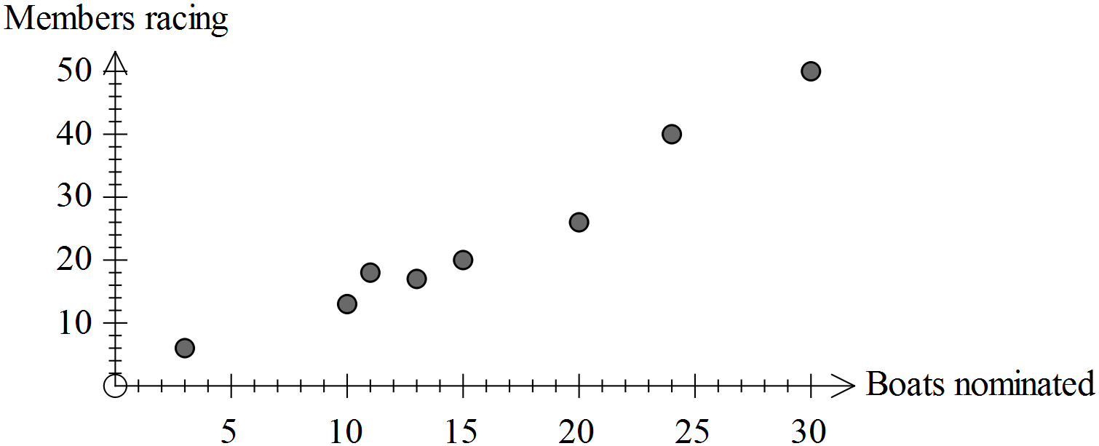

Describe the association between the two variables in terms of direction, form and strength. For each of these 3 aspects, justify your conclusion in terms of the nature of the scatterplot.

**Question 2 (9 marks)**

(a) Use the recursive definition to determine the first three terms of the sequence.

(2 marks)



(b) Use the rule for the *n*th term of the sequence to determine the first three terms.

(3 marks)



(c) Write a recursive rule for the sequence 994, 987, 980, 973, ...

(2 marks)

(d) Deduce a rule for the *n*th term of the following sequence. (2 marks)

1000, 100, 10, 1, ...

**Question 3 (9 marks)**

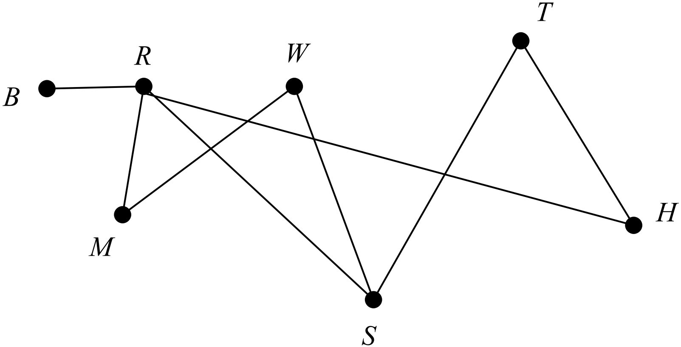

(a) State the degree of vertex R. (1 mark)

(b) Do any of the edges form a bridge? Justify your answer. (2 marks)

(c) The graph is semi-Eulerian and it contains an open trail. Name the vertices which form the trail in order. (1 mark)

(d) Redraw the graph as a planar graph. (1 mark)

(e) Verify Euler’s formula for the planar graph you have drawn. (2 marks)

(f) Is the graph bipartite? Justify your decision. (2 marks)

**Question 4 (10 marks)**

The graph shows the relationship between the number of internet users per 100 people and the number of mobile phones per 100 people. Each dot represents a different country.

The equation for the least squares line which is drawn on the graph is *y* = 0.4 *x* + 3 and the coefficient of determination is 0.3345.

(a) What is the response variable? (1 mark)

(b) Use the equation to predict the number of internet users when there are 200 mobile phones per 100 members of the population. (1 mark)

(c) Comment on the reliability of your prediction. Give two reasons to justify your conclusion. (3 marks)

(d) The least squares line crossed the vertical axis at approximately (0, 3). Describe what this means in terms of the number of internet users and the number of mobile phones. (1 mark)

(e) Describe the significance of the 0.4 in the equation of the least squares line.

(2 marks)

(f) Circle the dot that represents the country with the least number of internet users given the association shown by the pattern of dots and the least squares line.

For this country use the position of the line to estimate the difference between what was expected and what occurred. (2 marks)

**Question 5 (9 marks)**

Five badminton players are competing in a tournament. Their progress can be represented by a directed graph where arrows point to the person who has lost. A summary of the players results to date are

* Jon (J) has played all other players and beaten everyone except Nat (N).
* Kay (K) has only played two matches, losing to Jon but beating Len (L).
* Min (M) has beaten Nat and Len, lost to Jon and has one match still to play
* Nat has only lost to Min and only beaten Jon and Len.

(a) Use the information to complete the directed graph below. (4 marks)

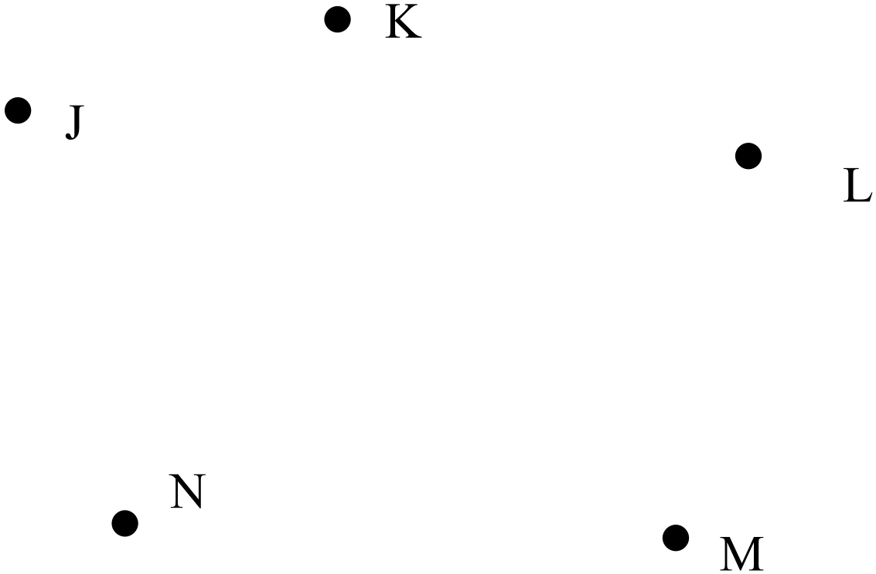

(b) Construct a 5 x 5 matrix in which each row and column represents a different person. The entry in row *i* and column *j* is a 1 for a win (person for that row has defeated the person for that column) and 0 for a loss or a match not played. Label each row and column with the person’s initials. (5 marks)

**Question 6 (7 marks)**

Year 12 students were investigating the use of mobile phones while driving. They were interested in finding out the extent of the problem.

(a) Create one question the students need to ask to clarify what is meant by “driving” or by the “use of mobile phones”. (1 mark)

(b) One numeric variable that could be useful for their investigation is

*The time spent texting while driving each day*

Describe two other numeric variables that could be useful for their study. (2 marks)

(c) Describe two ways by which the students could collect data relevant to their investigation. (2 marks)

(d) Other information indicates a positive relationship between the time spent texting and the likelihood of being involved in an accident. Does texting cause accidents or is the association between texting and accidents due to coincidence or confounding?

(2 marks)

**End of Questions**

Additional working space

Question number: __________________

**Acknowledgements**

Data for Question 4 were retrieved from the UNICEF website.

© MAWA, 2017

This examination is Copyright but may be freely used within the school that purchases this licence.

* The items that are contained in this examination are to be used solely in the school for which they are purchased.
* They are not to be shared in any manner with a school which has not purchased their own licence.
* The items and the solutions/marking keys are to be kept confidentially and not copied or made available to anyone who is not a teacher at the school. Teachers may give feedback to students in the form of showing them how the work is marked but students are not to retain a copy of the paper or marking guide until the agreed release date stipulated in the purchasing agreement/licence.

*Published by The Mathematical Association of WA*

*12 Cobbler Place, MIRRABOOKA 6…*